**Week 6**

**-Tanisha Gotadke**

**1BM21CS229**

**Query 1**

List the name of managers with maximum no. of employees

select e.ename,count(*) from employee w, employee e where w.mgr_no=e.empno group by e.ename having count(*)=(select max(mycount) from(select count(*) mycount from employee group by mgr_no) a);

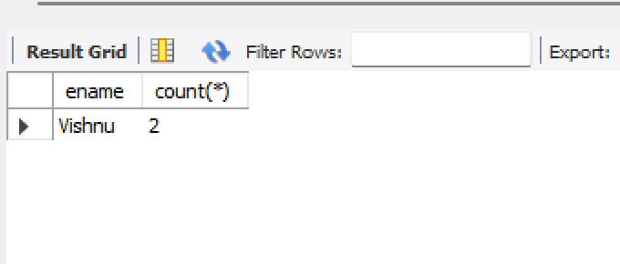

**Query 2**

Display manager name whose salary is more than avg salary of his employees

select empno,ename from employee e1 where e1.sal>(select avg(sal) from employee e2 where e2.mgr_no=e1.empno);

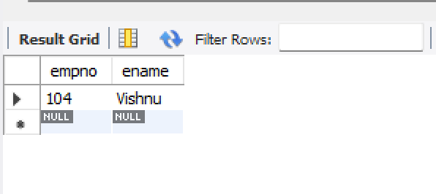

**Query 3**

Find name of the second top level managers of each dept insert into employee values (111,'Ken',102,'2008-07-10',6000,1);

select ename from employee e1 where e1.sal=(select max(sal) from employee e2 where e1.deptno=e2.deptno and e2.sal not in(select max(sal) from employee e3 where e3.deptno=e1.deptno)) and exists(select empno from employee e4 where e4.mgr_no=e1.empno);

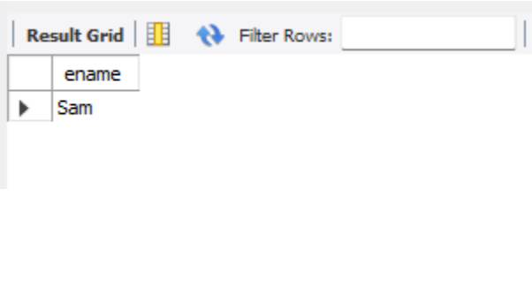

**Query 4**

Find employee details who got 2nd maximum incentive in Jan 2019 insert into incentives values (105,'2019-06-03',30000),(110,'2019-07-08',35000);

select e.empno,e.ename, max(incentive_amount) from employee e,incentives i where e.empno=i.empno and incentive_amount!=(select max(incentive_amount) from incentives) and incentive_date like'2019%';

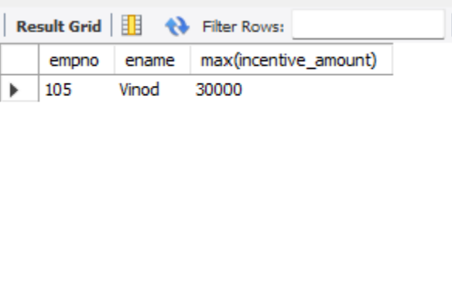

**Query 5**

Display those employees who are working in same dept where his manager is working select e.ename from employee e where e.deptno=(select deptno from employee e2 where e2.empno=e.mgr_no);

